Forward Rate Import Configuration

# Update System Configuration

The *service.properties* file will need updating. The following lines need to be added towards the end of the file, after the last configured service.

# Rate Feed

service15 = Rate Feed

service15.defaultLoc={hostName}

service15.stream = RvRateFeed

service15.args = LogFile|{logPath}/rates.log, Jvm|{javaExe} -Xms8M -Xmx16M -DRatesCacheOn=Y -Deurobase.class.path=siena.rvfeed.class.path

service15.panelName=RateFeeds

Change service15 to be the next available service number.

# Start the Rate Feed Service

Start the *System Manager* and start the new *Rate Feed* service.

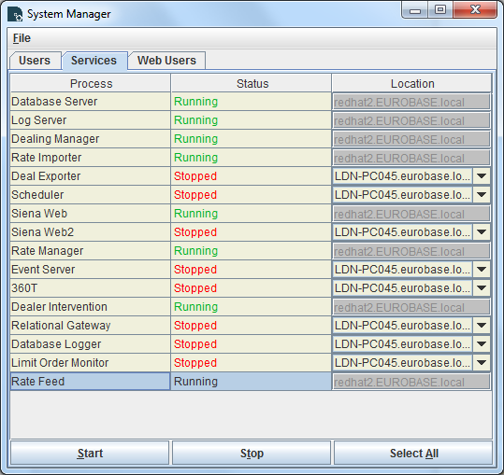

# Configure the Rate Feed Service

1. Start the *Services Manager* and select the *Rate Feeds* tab.
2. Select the *RvRateFeed* line.
3. Select *Rates File* in the combo box
4. Enter the path to where the RvServer spread sheet will place the RVMARKET rate file. Note this will be from the perspective of where the Rate Feed is running. E.g. C:\RateImport\RVMARKET
5. Hit <Enter> and then click the *Set* button

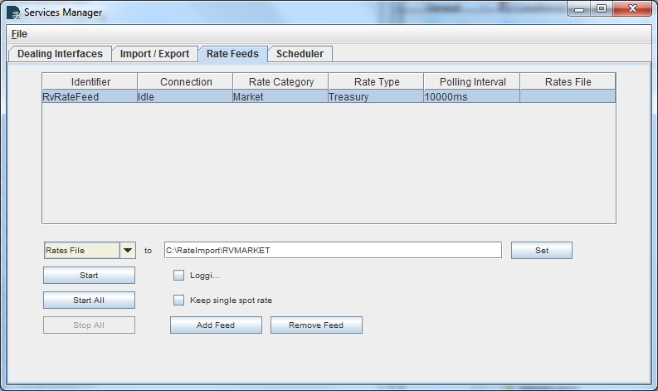

1. Click *Start All*

# Configure the Rate Spreadsheet

1. Open the Forward_Rates.xls spreadsheet
2. Edit the *Import Directory* to point to the same folder as used when configuring the *Rates File* field for the Rate Feed service above. E.g. C:\RateImport

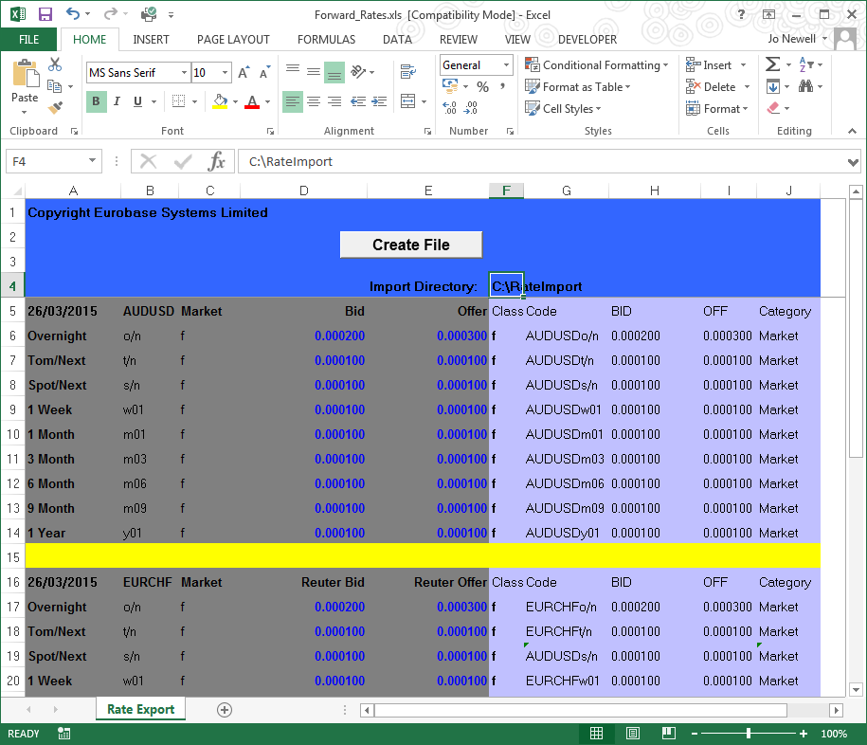

1. Click *Create File*
2. Check Rates have been imported

Open *Rates Maintenance* and check that the rates have been imported

# Restarting the Rate Feed Service

This configuration only needs to be done once. However, when the system is restarted, the *Rate Feed* service will need to started from the *System Manager* and *Start All* clicked on the *Rate Feeds* tab of the *Services Manager*.